**[BLUEROBOT.COM](http://bluerobot.com/" \o "BlueRobot Home)**

[**A List Apart**](http://www.alistapart.com/)  
[**Greasy Skillet**](http://greasyskillet.org/)  
[**Roy Rosenow**](http://royrosenow.com/)  
[**SwankyAl**](http://swankyal.com/)  
**Fake Link One**  
**Nothing Here**  
**Links Nowhere**  
**Fake Link Four**  
**Fifth Fake Link**

**Right Menu**

This layout uses essentially the same markup as [**Two Column-Left Menu**](http://bluerobot.com/web/layouts/layout1.html), but with a different stylesheet, title, and content. As is the case with most layouts in the Reservoir, the order of elements (header, content, menu) in the HTML source is friendly and accessible to mobile computers, text-based browsers, and alternative/accessible devices.

Much effort has been made to ensure that the layouts in the BlueRobot Layout Reservoir appear as intended in CSS2 compliant browsers. The content should be viewable, though unstyled, in other web browsers. If you encounter a problem that is not listed as a known issue, I am most likely not aware of it. *Please* [**email me**](mailto:rob@bluerobot.com?subject=Layout%20Reservoir) a heads-up. Your help will benefit the other five or six people who visit this site.

[**< Return to the Layout Reservoir**](http://bluerobot.com/web/layouts/default.asp) :: [**View the CSS**](http://bluerobot.com/web/layouts/view_css.asp?layout=layout2)

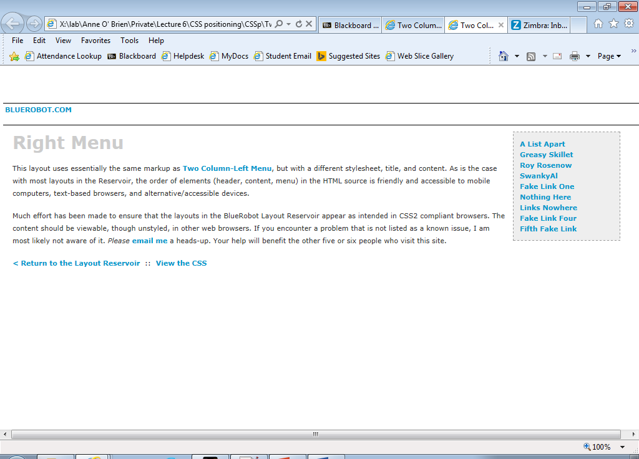

body {

font-family:verdana, arial, helvetica, sans-serif;

color:#333;

}

h1 {

color:#ccc;

}

a:link {

color:#09c;

}

a:hover {

background-color:#eee;

}

.Header {

text-transform:uppercase;

}

.Menu {

line-height:17px;

}